1. Given the provided data, what are three conclusions we can draw about Kickstarter campaigns?

As parent category wise, theater, music and film video are the most successful ones. No success on journalism, 24 campaigns are cancelled. Half of the campaigns of 4114 are successful, so we can say the campaigns are %50 successful in general.

1. What are some limitations of this dataset?

This is not comprehensive dataset for global purpose. 4114 campaigns results would be deceptive for 20 countries. But overall, the campaigns are successful.

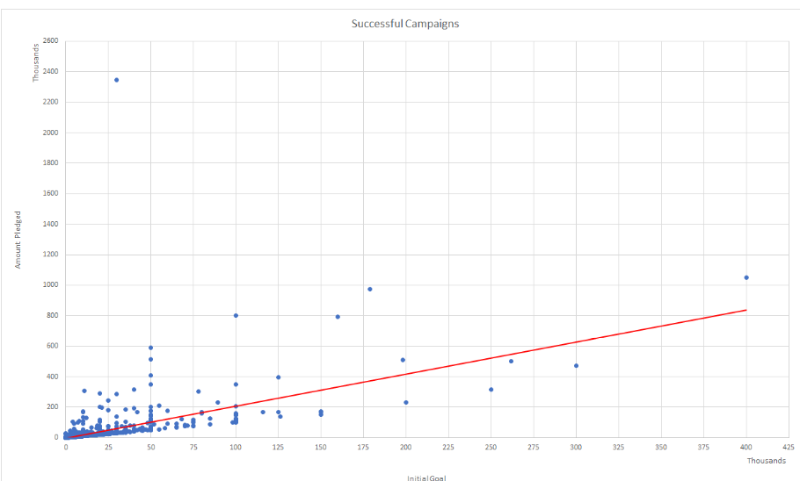

1. What are some other possible tables and/or graphs that we could create?

* Can be created to see per parent category each month instead of per category under filter tab.

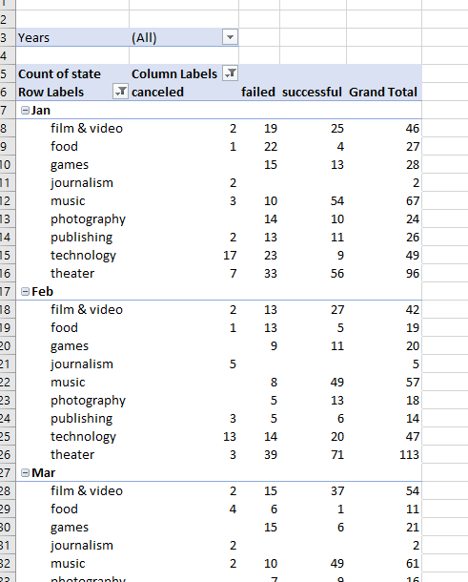

* Can be created sum of pledged per each month and year.
* Can be created average donation by state and month and year

There are many ways to read this excel and create many tables with the given excel spreadsheet.

I can say that the most successful country is US for this campaign and next is GB. More successful in campaigns in US again next GB. Singapore has only one campaign which is successful.

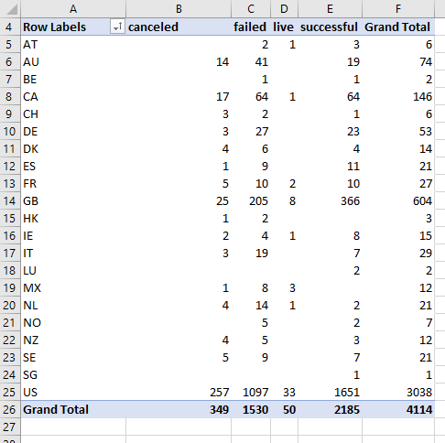

The data set can give us so much information to find out about these campaigns.

As per category theater, music and film video are the most successful ones. No success on journalism, 24 campaigns are cancelled.